COLUMNAR TRANSPOSITION CIPHER

Problem Statement: To encrypt a given text to columnar transposition cipher with key. Decrypt the given text with or without key.

Encryption: The input text and key (unique characters) is taken as input. The spaces of the text are removed. The text and the key are passed to a function called arrange. Which arranges the text in columnar fashion with the key of the key as the number of columns.

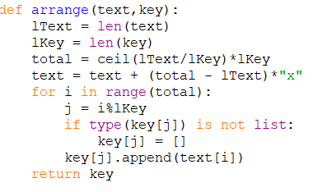

Here every character of the text is placed in the adjacent columns. Once one row is filled the next set of characters are appended to the next row and are added in column fashion. This is done by have j equal to index of current character by the length of key which places the character in its appropriate place in the list.

Remaining columns which are empty are filled with ‘x’.

This list is returned back to the main function.

Then the new list and the key are sent to another function called ‘encrypt’.

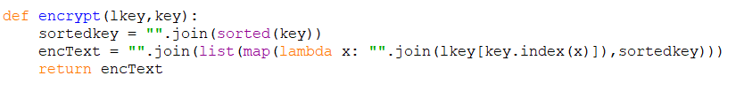

We sort the key alphabetically and then join that column first to a string. With this function the text is completely encrypted.

Decryption with Key:

Decryption pretty much follow the same procedure.

Here the encrypted data and the key are taken as input.

Both the text and the key are passed to function called ‘darrange’.

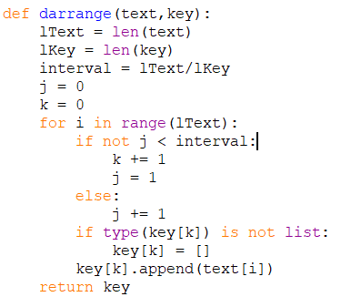

Here, in the encrypted text the first ‘lkey’ (key length) length of characters belong to one column and this keeps repeating until all the text are moved to a list. This list is returned and passed to a function called ‘decrypt’ along with the key.

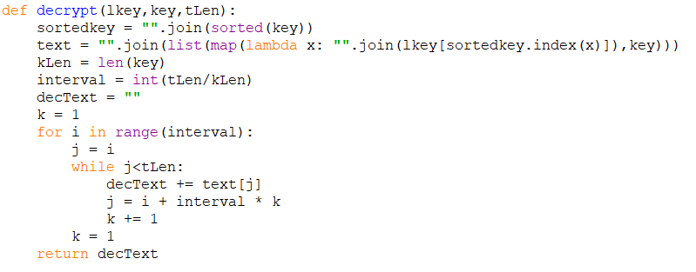

Here we first arrange the list of lists in the order of the characters of the key.

Then every row of that list of lists is first joined and then moved to the next row this is done by the for and subsequent while loop.

Finally the decrypted text is returned.